Kaarel Part

Evaluation section of the NEA coursework
Evaluation
Computer Science NEA

Contents
Evaluation 2
Effectiveness of the programming language and the tools you have used. 2
Compared your system to the commercially available systems in your investigation 2
Identified good and weaker aspects of your system, identifying what you would have liked to have done better. You don’t actually have to make these improvements so you can be imaginative!! 3
Explained your strengths and weaknesses in the design and development of the system 3
Identified any personal changes you would make if you were asked to repeat the process to avoid any of the above weaknesses. 3

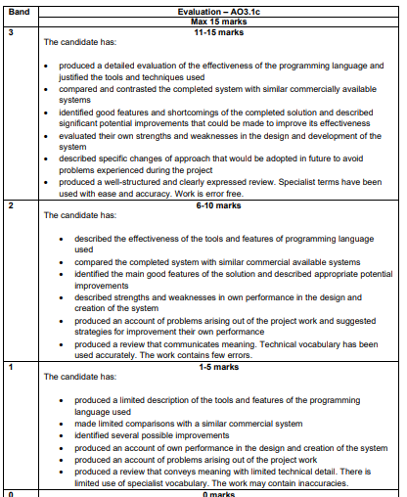

This is for your reference only and needs to be deleted when it is handed in as a final copy.

Please also delete any of my comments from the sections below, on final hand in

Evaluation

Effectiveness of the programming language and the tools you have used.
Firstly, python was an excellent choice as not only it is what im best at and contains all necessary components with easy-to-use frameworks and sdk to make it quick enough and stable. the main libraries/components I used was sqlalchemy for all the database stuff and an Orm to make database parts more integrated with the whole project by using python syntax to manage it. Then flask was for the web components with also gunicorn setup for a proper deployment if it would ever actually be used, however most of the time I used flask to deploy it due to having hot reloading and it fit all my needs and was easy to use so im very happy with that. Bootstrap CSS was also highly effective as it had templates for all the components on the website that I would use and they looked better than what anything I could have made so im happy with them too. One tool I used was git to have version control and not only was it effective at having great backups of the whole project, saving me multiple times accidentally deleting a python file etc, it also helped me learn about version control management a lot more. Uv by astral however was the most effective and useful tool I have used yet for programming. Having to deal with python environments and pip not working on some machines was definitely a headache, and the genius idea of just having a local python version and all packages and virtual environment in the all in the project folder isolated from the system so no incompatibilities occur while also making the requirements file be auto checked for incompatibilities between the libraries was a total life saver. It singlehandedly increased my productivity by two times just because of how much it removes all the hurdles of boilerplate it takes before you can write actual codes. Now obviously it has not written any code but all the git stuff, pyproject configuration and formatting the python code was done by it. Visual studio code is the last tool I used and that was also incredibly effective. Having to do all this in IDLE or some other editor would just add so much more friction to be able to write code. Also having integration with git made it much easier to work with it as well. Syntax highlighting is probably my most favourite feature of it as it makes skimming through and getting to where I was so much better. Docker, a containerisation tool for programs, was also a small thing I added at the end to have it deploy easier. As I already had it in GitHub, I could use GitHub actions which automate actions with the code e.g. update libraries, format code whenever pushed etc, also has the possibility to make docker images. And so, when testing instead of having to install python all the requirements, all I need to do is docker run then the container name from GitHub and im ready. Also keeps it a lot more controlled which is always a plus. Python-Mailjet library was also nice, so I do not have to worry about smtp and use a restful API to send all the emails/notifications this project needed. Now obviously this is only for coursework, so it is not exactly production ready. It does have all the essentials and the main quality of life a user would expect, some users may even appreciate it being less as it makes it easier to use. However, a lot could be added to make it more competitive with others. One big thing is that a lot look a lot nicer to use and having clear. Using python does make it easy to make but if you would do this properly for a large-scale system, you would use proper web technology and languages (e.g. js html CSS combo, react framework etc.). skedda is a great example of what im talking about as a proper meeting room booking system. They have all these extra widgets that don’t change mut at the backend but at the frontend make it so much easier for the user to use and just makes them prefer it over anything else. Calendars/timetable selection in my opinion is where this most shines where having instead of just a form fill out with dates, it’s a physical block of time they can move around, and it makes it a lot easier therefore for them to use. Little things like these, these quality-of-life features would’ve made this so much better, but these features are made only for proper systems using the original native languages, not some wrapper so that its all done in python. Another is existing system integration. What I mean by this is for example teams so that all of this can be managed through it, therefore not needing any extra separation and therefore confusion. All the main ones (Skedda, Accruent EMS, Envoy, Robin) have this prebuilt in so that it’s easy to adapt and unfortunately my project does not. It involves setting up all the API endpoints offered for these teams like programs like slack etc and it would have to be done for all these separately, meaning a lot of extra work both in coding and testing that would not even be used when this is all submitted. In terms of design part of the system, I went overboard with features to be added to the system than what I made. The original design for example was to have an extra interface on a separate device to use NFC technology to scan a keycard in front of the meeting room, to physically and instantly book a room if its empty. I should have realised at the start that I was never going to go ahead with that as it would have required me to not only get a device to try to get all this working but also probably learn how to setup an entire protocol for the nfc. Also connecting everything to be shown in a demo would be a nightmare as the computers at school lack any permissions for external devices to be linked to each other. Another would probably be more testing. Even though I did cover all the places an user could input I didn’t go to the point of testing every single type of testing whether it be length check, empty check, format check or similar, therefore the system isn’t technically completely tested so definitely in the future if I would make something like this again I would cover it in more detail. Maybe also look into unit testing if doing testing on a more headless project that can be tested with mock data so that I get quickly test the whole system at once if I try out something in a version.

